Lesson 21: Secure Hope IIb
NASB
Romans 8:28-39
²⁸ And we know that God causes all things to work together for good to those who love God, to those who are called according to His purpose.
²⁹ For those whom He foreknew, He also predestined
to become conformed to the image of His Son, so that He would be the firstborn among many brethren;
³⁰ and these whom He predestined, He also called;
and these whom He called, He also justified;
and these whom He justified, He also glorified.
³¹ What then shall we say to these things?
If God is for us, who is against us?
³² He who did not spare His own Son, but delivered Him over for us all, how will He not also with Him freely give us all things?
³³ Who will bring a charge against God’s elect?
God is the one who justifies; ³⁴ who is the one who condemns?
Christ Jesus is He who died, yes, rather who was raised, who is at the right hand of God, who also intercedes for us.
³⁵ Who will separate us from the love of Christ?
Will tribulation, or distress, or persecution, or famine, or nakedness, or peril, or sword?
³⁶ Just as it is written, “For Your sake we are being put to death all day long; We were considered as sheep to be slaughtered.”
³⁷ But
in all these things we overwhelmingly conquer through Him who loved us. ³⁸ For I am convinced that neither death, nor life, nor angels, nor principalities, nor things present, nor things to come, nor powers, ³⁹ nor height, nor depth, nor any other created thing, will be able to separate us from the love of God, which is in Christ Jesus our Lord.

Introduction
We are at the very end of the second major section of Romans. The first major section of Romans answered for us the first question of covenant, “What makes me acceptable to be in relationship with God?” Paul taught in those chapters that a person does not make himself righteous but is declared righteous by grace through faith in Jesus Christ. You are acceptable 100% because of what God has done and 0% because of what you have done.
That answer creates a perceived problem. Paul’s opponents insist that children accepted 100% by grace will abuse that grace. Grace produces spoiled and sinful children. Children of God must be put under law. They must be required to complete some action, some duty, some moral performance to earn or maintain their status in the family.
Paul turns to that problem in chapters 5-8, and he rebuts the false assumption that grace must produce rotten children. He says, “May it never be! In fact, grace is the only way to produce righteous children because in relation to human flesh, an external law is too weak to succeed.”
Paul’s desire in chapters 5-8 is not primarily to answer the opposition question. Paul is more of a pastor than an apologist. His answer is not developed for non-believers, but for believers, to help establish us more firmly in the gospel of Jesus Christ. Chapters 5-8 help us answer the second question of covenant. “Now that I am in relationship with God through grace, how then do I live under grace?” We can come at this question, “How then do I live under grace?”, two different ways. We can come at it theoretically, or we can come at it practically. Here is the difference. Coming at it theoretically means to learn the theory or principles of living out grace. Coming at it practically means to learn the practices of grace. What do we say, and do, and think.
Normally, I would be for the practical, because there is often way too much talking and listening in Christianity and not enough doing. But in regard to living out grace, one of our biggest mistakes is jumping into the practical without ever coming back to acknowledge that we don’t really understand the theory of grace. Living out grace does not come natural to human beings. We are legalists at heart. So, if we are to live out the gospel of grace, we really need to stop and think about the principles of grace. The new covenant is a new wineskin. We need to know how this new wineskin functions differently than the old. That is what we have been doing in Romans 5-8. Paul is teaching us the principles, the theory of grace. That’s why, even though this section is addressing the question, “How then do I live?”, we have only received two commands in four chapters: consider and present. That’s because this is Paul’s theory or theology of living out grace. Paul would never leave out the practical. He is going to get there with the application of grace in chapters 12-15, but he does want to make sure we understand the theology of grace first, so that we do not jump into the practical and live it out as though we are under law. That is the big mistake I referred to early. We move from saved by grace to doing the commandments without considering how we should go about doing the commandments under grace. We jump to “show hospitality, pay your taxes, accept one another.” And that is good. Nothing wrong with getting practical really early. But we need to take a pause in there at some point and ask, “What does it look like to show hospitality under grace? How is that different than showing hospitality under law? Am I doing this the right way, out of the right heart and with the right source of strength? How does grace motivate? How does grace empower?”
This is why Paul has written Romans 5-8. To help us understand what it means to live under grace. We need to come back to these principles again and again and again, so that they affect how we see the world and live in it. We come back to our new identity in Christ, to our new union in Christ, to our new invitation in Christ. I will remind you again of these things at the end of this lesson. But we are not quite at the end yet. We still have one of the most beautiful texts in all of Scripture to cover in Romans 8:28-39. And in doing so, we come back again to one of Paul’s most emphasized principles of grace, our secure hope in Christ.
For Paul, embracing the new security we have in relationship with God is crucial to living out grace. We know it is crucial because it is how he begins the whole section in chapter 5 and it is how he ends the whole section here in chapter 8. Recognizing your secure hope in Jesus Christ is foundational to your ability to live under grace and not under law as a Christian.
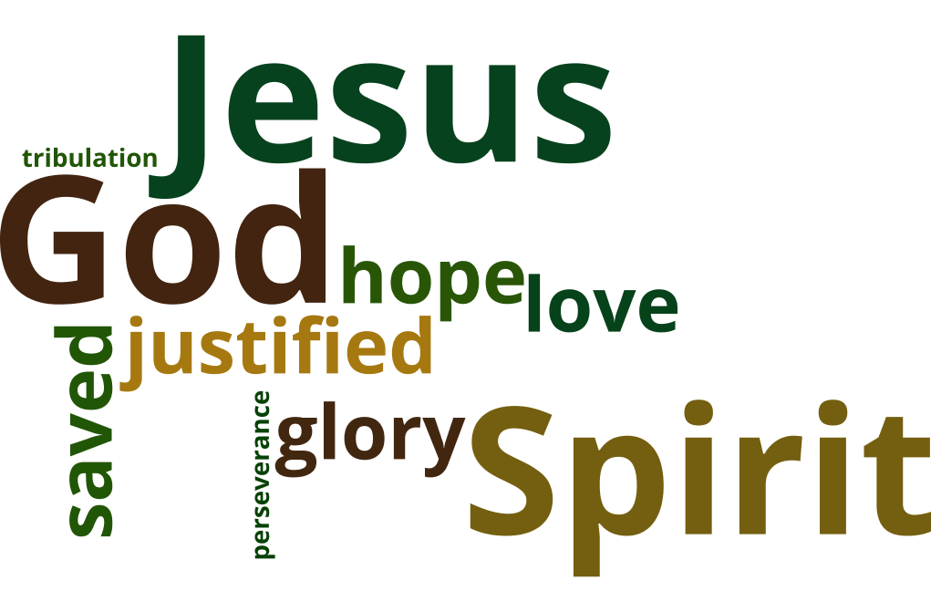
Our theory of living out grace starts and ends with this wonderful truth. “You are safe in the love of Jesus.” This was the theme of chapter 5:1-11, and this is the theme of 8:18-39. Remember back in the lesson on 5:1-11 we recognized that there are certain words and ideas repeated at the beginning of chapter 5 and then only again at the end of chapter 8. And they indicate the parallelism of the two sections. They show us that indeed Paul is ending just as he began. The words are justified, saved, tribulation, perseverance, glory, hope, and love. Along with those terms in both sections Paul highlights the trinitarian work of God the Father, God the Son and God the Holy Spirit. He is communicating to us that in spite of the ongoing suffering we will experience in our already/not yet state, our justification in Christ Jesus has made us safe in our relationship with God. We persevere in the firm conviction of our hope that we will one day enter into the glory of the Father. The Holy Spirit witnesses to our spirit by filling us with love for the Father and with experiential knowledge that we are sons and daughters. And though this work of the Spirit strengthens our hope it is not the basis of our confidence. Our assurance is grounded in the love of God and the sacrifice of Jesus. God is saying, “You are safe. You are loved.” This is the message of the first question of covenant that Paul wants us to hear before he goes into answering the second question of covenant. Before we address the struggle of being righteous, he assures us that we are already declared righteous in Christ and acceptable to the Father. And I love the literary structure of chiasm that Paul has used in chapters 5-8 that parallelism that goes through the whole section with these two sections of our secure hope being at the beginning and end of the section. To me it feels like the two strong arms of God wrapped around me his child as I engage in living out grace. I can step out and attempt to live in his Spirit and attempt to put to death the deeds of the flesh and attempt to present my members to him in righteous because I know, I know that I am held firmly in his loving embrace. I am secure. I might fall, often, hard. I mean I might seriously mess up. But I know, I know this, he is never going to let go of my hand.
We saw this declaration of security in chapter 5. Let’s reconsider here in chapter 8 what it means to be safe in the arms of God.
We are looking at Romans 8:28-39. Verses 28-30 really go with our previous lesson. So, we will pick up with 28-30. That will be the first part of this lesson. And then we will turn to the second part in verses 31-39.

God’s Sovereignty Over Our Salvation (8:28-30)
[Read Romans 8:28-30]
It is easy to allow a discussion about this text to be derailed by a debate on predestination. Interestingly with Paul, two of his main texts including predestination, this one and Ephesians 1:3-14, are presented to us without any consideration of a problem with the idea of predestination. Paul doesn’t go into any kind of problem or how it works or anything about free will. But rather, he gives us the idea of predestination to encourage us as we reflect on the wonderful blessing we have in God. He just puts it out there.
And Paul intends here in Romans 8 to encourage us with the truth that God has all things under control. He does not give us the how of predestination. He gives us the truth of predestination to strengthen our conviction that God’s wisdom and power will surely bring about what God has planned. We will address questions about predestination some in chapter 9 because that’s where Paul gives us more to work with. That is where he addresses it himself. Here I want us to receive the comfort that Paul is offering without getting distracted by the philosophical questions of how does predestination work. But in order not to be distracted, I think I do need to make a couple of brief comments.
The question for predestination tends to revolve around whose will finally brings us into the kingdom of God. It is not a question about whether people have free will to do anything. It is a question about salvation. Does a person have the ability to receive God’s gift of grace? Or is that something God must do for a person? Is faith an act of free will or is faith a gift of God? We can imagine a door with God on one side and an individual on the other side divided just by the threshold. God is calling the person to enter through the door. When that person steps through, whose will caused that step to take place? Whose will is primary? Did the person decide on their own to step through? Did God decide for them and cause them to step through? Is it somehow both? That is the big question of predestination and those are pretty much the three options.
When we come to Romans 29-30, we have this process. God foreknew, predestined, called, justified, glorified. Thinkers who believe that an individual’s own will is decisive in moving them through the door into relationship with God have suggested that God foreknew those who would believe in him. In other words, he saw ahead of time who would step through the door. And then he determined ahead of time or predestined that he would conform those people to the image of his son those who chose to believe in Jesus. As a result, he called those he knew who would respond. They responded and so were justified and then glorified. That is a possible free will interpretation of this text. So, foreknowledge really is about God looking ahead to see who would choose him.
My thinking is that God’s will is determinative in bringing us across the threshold into his kingdom, so I do not have a need to figure out how free will fits in to the process here of our salvation. Whatever Paul thinks about the free will question, he does not explain it right here. And he did not offer this text to the Romans as a philosophical mind twister. I believe that Paul assumed his first listeners would receive this as an encouraging way to understand the suffering and struggle of their own Christian lives.
We touched on verse 28 in our previous lesson following the three groanings. The context leading up to verse 28 is the recognition by Paul back in 8:17-18 that Christians walking in the power of the Holy Spirit will suffer. That is a promise. We also recognize that this suffering is not worth comparing with the glory to be revealed in us once God has made all things right. This does not mean, however, that Christians are expected to be emotionally free from the pain of grief and suffering. The brokenness of this world and the brokenness of our own flesh cause us to groan as we look forward in hope to the glory that will be. Our groaning is validated by the fact that the Spirit of God groans with us in our present struggle.
Having recognized our struggle and our groaning in that struggle, Paul is now bringing us back out again from our individual challenges to this broader principle that “we know God causes all things to work together for good.” He does not say that all things are good. And he does not say that each thing will be made good. You might get fired and not regain your job. You might have a boyfriend cheat on you. You might have a child who dies of leukemia. Your house might be flooded or catch fire. God may choose to protect you from anyone of these things. Or he may choose to let it happen and to show you the good that’s happening through it. But he also may not. He may not protect you, and he may not reveal to you what he is doing. So, regardless of the present evil and regardless of what we see or know, this is our sure conviction that, in the end, God will have worked the good and the bad together for your good. You are being made fit for heaven. You are being made fit for eternal life with God. Your life affects the lives of other people. Your life is part of God’s plan to weave all things together in one glorious tapestry as he brings about the restoration of all things. And so, you can trust that all the good and all the bad will come together in God’s plan for your ultimate good.
Though in the text there is one caveat. God is doing this for those who love him and are called according to his purpose. This is not a promise for those who hate God, who reject God, who do not receive his gift of grace. For them, they cannot look ahead believing all is going to work out for good in their case. This is also not a challenge to love God more. He is not saying, “If you love me, I will do this.” He is saying that this is the truth about those who love me, and the ones who love me are the ones who have been called according to my purpose. If you have been called, you are indwelt by the Spirit. If you are indwelt by the Spirit, then the love of God has begun to take root in your heart. You love God if you are in the Spirit. Not all the time of course. But you are the ones who love God. It is not something you have to do, it is simply a fact about you. And those who love God are the ones who are going to experience this reality that he is going to bring everything together in the end for good. If you are in Christ it is talking about you. In fact, it is not so much based on you being the one who loves God, as it is based on God being the one who loves you. He foreknew you. He set his eye on you from afar. He predestined or predetermined in his mind that he would bring you home, and you can be sure he will accomplish this.
I believe the force of the word “foreknowledge” here lies in the idea of love, not in the idea of seeing ahead what might happen. It is in accord with Paul’s encouragement in Ephesians 1:4 that God chose us in Christ before the foundation of the world. The idea is that you are known by God in advance. Your love for him is a result of his having known you first. Having known and loved you even before you were born, he determined ahead of time that you would be conformed to the image of His son, that you would participate in the redemption and restoration of humanity.
Let’s talk about that a little, about what it means to be conformed into the image of God. The image of God was the original glory of Adam. In a sense, our glory is secondary glory. We are like the moon. A full moon lights up the night, but not with any light of its own. The moon reflects the light of the Sun which is the true origin of the light. God is the sun, the source of glory, and we are to be little moons reflecting his glory as it shines out of us. By placing his own moral character into Adam and Eve and giving them real authority and ability to rule and to love and to create and to judge, God made his own image to be reflected in them. This image was marred by the fall into sin. So, the second Adam came to reflect that image and to restore fallen man and woman, to bring us back into accord with our original purpose as image-bearers. This is the good that God is working in you, that you would be conformed to the image of Jesus, taking up your purpose as a true son of Adam or true daughter of Eve. Jesus Christ would be the firstborn among many brothers and sisters.
Now, let’s continue with the process in verse 30. Having predetermined that you would be part of this glorious restoration of humanity, God called you. That call awakened in you the eyes of faith. You saw Jesus and believed. Having been called, then, you were also justified, declared right. Having been justified you are also glorified. Interestingly, Paul puts this last term in the past tense along with the rest even though through this passage God’s glory is something we are looking forward to in the future. We are not yet glorified but will be glorified in the new heaven and new earth. I think Paul uses the past tense “glorified” here to indicate the absolute surety of God completing the process. If you have been justified, then you will indeed be glorified. It is as good as already done.
Looking at this process that Paul lays out, it is worth asking, “Where is the human part?” The point of chapters 5-8 is to answer the second question of covenant, “How ought we live out this covenant of grace?” Paul gave us the commands of grace in chapter 6 to “consider” what is true about ourselves in Jesus Christ and to “not present” the members of our body to sin but to “present” the members of our body to righteousness. And again, in the first half of Romans 8, we are told to put to death the deeds of the body and live by the Spirit. So, having these exhortations here in these chapters to live out grace, it is interesting to note the omission of any human part in this process.
In between called and justified we might expect to see the word believed. That’s the human part. And in between justified and glorified we might expect to see the word sanctified. Paul is focusing our attention on God’s part; foreknown, predestined, called, justified, glorified. The implication of Paul’s communication is that the beginning and the end are in the hands of God. After you are justified, yes, you are called to struggle, to engage your mind and your will and your heart, to make wise decisions, to pursue righteousness, to reflect the image of God, to participate in becoming who you have been created to be. And that is all part of your sanctification, your transformation, your growth, your maturity. And yet, in all your effort, do not misjudge who is the primary player even in that process. God is leading this dance. The beginning is 100% in his control. It is God who has justified you. And the end is 100% in his control. It is God who get you to heaven, who will glorify you. You do participate in between those two, in your already but not yet reality, having been saved, but not yet taken home. You participate, you are learning to rely on the Holy Spirit who dwells in you to guide you and empower you. But even then, God is still the primary agent. You participate, but He is the one working in you to desire and to do (Phil 2:13).
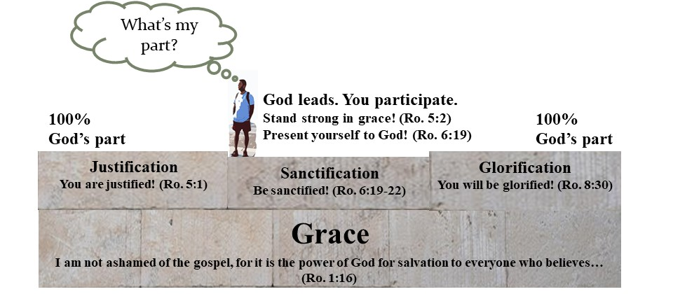
Paul has here described for us God’s sovereignty over the process of our salvation and he intends for us to receive the reality of God’s sovereignty as good news. Knowing that God is the one ultimately in control of every stage, strengthens us and reinforces us to engage in our part.
So, what conclusions can we draw from Paul’s description of God’s sovereign hand overseeing our justification, sanctification and glorification?
Well, let’s read and see what Paul says in the final paragraphs of chapter 8.

The Secure Hope of Our Salvation (8:31-39)
[Read Romans 8:31-39]
Paul piles up for us a list of questions that work on our minds and our hearts. We can draw out and focus on three of these questions. First, “If God is for us, who is against us?” Second, “Who will bring a charge against God’s elect?” And third, “Who will separate us from the love of God?”

If God is for us, who is against us? (8:31-32)
We start with the first question in verse 31. “What then shall we say to these things? If God is for us, who is against us?” Verse 32 gives us the idea Paul is driving at. “He who did not spare his own son, but delivered him over for us all, how will he not also with him freely give us all things?”
God made a plan to bring people back into relationship with him. That plan would cost the death of Jesus on a cross. Having determined to go ahead with the most costly part of the plan, did God not think it all through? Is he like the man who builds the tower and runs out of money half way through or like the king who goes to war without the ability to win? Was the death of Jesus just a role of the dice, risking all that God might redeem for himself a family, but might not? If God began the plan of the cross, would he not certainly have determined its end. The idea here is very similar to the idea in 5:10, where Paul says, “if while we were enemies, we were reconciled to God through the death of his son, much more, having been reconciled, we shall be saved by his life.” If we went this far, he is going to go all the way.
Paul asks, “how will God not also with Christ freely give us all things?” If God has made the gospel of Jesus Christ his plan of salvation for individual human beings, then what or who is going to prevent God from bringing his plan to fruition? If God foreknew you and called you and justified you, then what or who is going to prevent God from glorifying you?
That’s the question Paul is going to answer with more questions. We have two more to focus on.

Who will bring a charge against God’s elect? (8:33-34)
First, in verse 33, “Who will bring a charge against God’s elect? God is the one who justifies; who is the one who condemns?” Who is going to stop God by condemning God’s children? Who’s bringing the charge? Who’s going to condemn them?
There is one who condemns. The enemy of old, the accuser, Satan. I do not know if he will be allowed in the courtroom, but if he is, you can imagine he is going to join the prosecution against you. And in this he is not even going to need to deceive. As you stand on trial before God, you can imagine Satan, the prosecuting attorney, bringing in a big fat binder with your name on it. As Satan drops the binder on the stand before you, he opens to page one and commands, “Read this out loud.” You look at the judge. He nods. You begin to read. Satan smiles scornfully as he instructs you, “A bit louder, please.” The cold numbness of fear crawls up your legs and burrows into your stomach as you read line after line, knowing every sentence to be true, truer than you would ever admit to yourself; hypocrisy, laziness, impurity, harmful words, selfish deeds. Accurate in every word. After you finish the binder of sins that took place before you came to know Christ. Satan switches that with a new binder detailing the transgressions you committed after coming to know Jesus Christ. When the reading is over, the judge asks, “How do you plead?” As the word guilty begins to form on your tongue, the lawyer for your defense stands up. It says there that Jesus Christ is the one who intercedes for us. Jesus Christ who died and rose again. He submits one item into evidence, a wooden cross. And nailed to that cross is the entire list of sins just read and over that list. And stamped on that list are the words, in blood, “Paid in full.” The gavel comes down and the sentence is passed, “Righteous by means of grace.”
“Who will bring a charge against God’s elect?” When you have Jesus speaking for you, who can condemn you?
Actually, there is another accuser besides Satan who tries to condemn. It’s you. Sometimes you yourself speak the loudest words of condemnation. It is true that you have a deep, personal awareness of your own limitations, failings, selfishness, hypocrisy. You may have stored up the evidence against yourself in your own heart. But you are now in the hands of God. You have received his grace. The voice in your head may be loud, but it is not loud enough to overturn the court of God’s justice. He has paid in full. He has declared, “There is therefore now no condemnation for those who are in Christ Jesus.” The condemnation speaking so loudly in your own mind will be drowned out by one word, “Accepted. Accepted.”
So, enter into the rest accomplished for you by the Son of God. No one can bring a convincing charge against you. Not you. Not Satan. No one. And God certainly will not, because he has already paid the ultimate price for you, and he has already sealed you as his own with the Holy Spirit as a guarantee of your inheritance, to the praise of his glorious grace (Ephesians 1:13-14)!

Who will separate us from the love of Christ? (8:35-39)
In verse 35 we come to another question asking who or what will prevent God from completing the purpose of the gospel. Paul states it this way, “Who will separate us from the love of Christ? Will tribulation, or distress, or persecution, or famine, or nakedness, or peril, or sword?”
Paul has returned again here to the reality of our suffering in this broken world. That suffering which so often creates fear or doubt in our minds. Am I loved by God? Is he still holding me? Do these things that come against me in this broken world and as a result of broken humanity, do any of these things separate me from my relationship with God in Christ? Do these things show me that I am judged and cast out.
Paul says, “No.” He just says it much more beautifully. But the answer is, “No. Nothing can separate us from the love of God.” Let’s read how Paul says it. It’s wonderful.
“In all these things we overwhelmingly conquer through Him who loved us. For I am convinced that neither death, nor life, nor angels, nor principalities, nor things present, nor things to come, nor powers, nor height, nor depth, nor any other created thing, will be able to separate us from the love of God, which is in Christ Jesus our Lord.” Amen.
The victory that is ours is ours in Jesus. It is his victory. It was motivated by his love for us. Now that we are in him it is our victory, too. Paul is fully convinced in the security of this victory. Nothing can come between us and Christ. We will be with him in glory. The terms Paul uses should probably not be taken too specifically. He is painting here with broad strokes. Mostly the terms are in pairs. “Death” and “life” cover the normal way we think about our human existence, this life and the end which is death. “Angels” and “principalities” (or maybe you have “rulers” in your Bible). These seem to address spiritual beings, with angels possibly being reserved for the good powers and principalities for the demonic. Then we have “things present” and “things to come”. And these take a temporal perspective. They consider time. And they cover anything that we can remember in the past or anything that we might conceive of in the future. There are different suggestions for why “powers” occurs unpaired. It is by itself. I am not sure if any of the suggestions are convincing. So, we have “powers.” Then we have the pair “Height” and “depth”. And it is also not very clear what these mean, but if we stick with broad terms, they are special. This is the spatial dimension. And if we take it physically it’s the sky and then it’s under the earth or figuratively it’s heaven and hell. Then the last term “all created things” serves as a catch all in case we could conceive of anything being left out of the list so far. This covers it all, everything.
What can separate you from the love of Christ? Death cannot separate you from the love of Christ. Life cannot separate you from the love of Christ. An angel cannot separate you from the love of Christ. No demon can separate you from the love of Christ. Nothing in time, past or future can separate you from the love of Christ. Nothing in space can separate you from the love of Christ. No power at all can separate you from the love of Christ. Nothing in any form in this created existence can separate you from the love of Christ.
What can separate you from the love of Christ? Nothing. And to be honest, just from my own opinion, I think we must include you in there as well. I think the list is all-encompassing, implying that you cannot separate yourself from the love of Christ. You’re his now. He’s got you.

Conclusion
I once heard a doctor of child development speak to a group of future teachers. She said that there are two questions every child is instinctively asking of any adult who comes into their life. The first question is “Do you love me?” Or, “Do you care about me?” A child will easily dismiss an adult who enters a room and only talks to other adults. But an adult who looks the child in the eyes, bends down to their level, and speaks directly to the child, that adult catchers their interest. Their brain, even though they do not know it, begins to instinctively ask about this adult, “Do you care about me?” That little child’s brain is looking for signs that say, “You matter. I care. I will protect you. I will give to you. I will have fun with you. I love you.”
The specialist said there is a second question that the child asks also instinctively of the same adult. “Maybe you do love me. But can I trust you? Can I trust you.” That’s the question. “Even if you do really love me will you keep your promises? Are you a promise-keeping adult? Are you trustworthy?” When I heard the professional teaching, I thought, “Those are the questions of the human heart. Those are the questions we are asking about God, whether we know it or not.” I believe there is a longing in every human heart to have these questions answered. And we usually turn to other people to get them answered. We don’t know to turn to God. And we say, “Do you love me? Can I trust you.” But the questions come from a deeper place inside our souls. No human can fill that void or answer that longing. We long for God to fill this emptiness. The questions of our soul to God are, “Do you love me?” And, “Can I trust you?” And when we realize that those are the questions our heart, then we become ready to hear God answer.
Teaching in chapters 5-8 on the power of grace, Paul begins and ends by answering both of those questions. God says, “Yes. I love you enough to die for you when you could care less about me. I love you enough to adopt you as my child. And nothing in this world or any other world can prevent me from bringing you home. You can trust me.”
As the voice of the Holy Spirit works to rebuild our hearts, to reform and transform. And as we receive this truth that we are loved, that we are safe in that love, it does something inside of us. It creates a fountain of emotional wealth. It empowers us to reject the voice of condemnation in our own minds and to reject the voice that says, “Worthless.” Because we say, “No. No. I am loved by God. And he’s got me. I am safe.” It also empowers us to rest in God, to persevere through suffering with God, and also to turn our eyes from ourselves to others. We find that we begin to have emotional wealth to share, to care for the needs of others, to bear their burdens without grumbling or bitterness.
We have talked about the groaning that comes with the suffering of this life. And it is true that sometimes there will only be one pair of footsteps in the sand when God must carry you. He’s got you when you have no strength. That, however, is not the whole story of grace. There will be other times when you are the ones carrying your brother or carrying your sister. There is a grit to grace, a Mother Teresa kind of grit, a resilience, a fortitude, a resolve, an inner strength. Paul was quite serious when he said that we, we are those who are able to rejoice in our tribulations, because those tribulations produce in us perseverance and that produces in us proven character and that produces hope which excites us because we have the love of God in our hearts by the Spirit. So, we love hope. Because hope is pointing us home. This is by grace. By grace you are being made strong.
Let’s remind ourselves again of the principles of grace. What makes us so powerful? Let’s conclude with four things.
One, you have a New Identity in Christ: You are a child of God, declared righteous being remade into the image of Christ. Knowing that it is God who defines you, empowers you.
Two, you a have a New Union with Christ: You are united with Jesus spiritually in his death and in his life. His Spirit indwells you so that you might pursue righteousness and experience fruitfulness in this life. As you live by faith, the Spirit of God empowers you.
Three, you have a New Security in Christ: No one can condemn you before God’s court and no one can separate you from the love of Jesus Christ. Security in Jesus does not lead to sin but provides you with emotional wealth to be at peace with who you are as you live out this sometimes, painful state of transformation. That secure hope empowers you.
Four, you have a New Invitation: Grounded on your identity in Christ, your union with Christ and your security in Christ, you have received an invitation the invitation of grace to live as a new man or a new woman, as a grown child of the King. It is a command and it is an obligation, but there are no morality police standing over you to force you to it. God calls you based on the desire he has placed in your heart. The Spirit in you loves him. The Spirit in you calls him Abba, Father. So, regardless of what sort of obligation others may enforce on you externally, you have inside of you this deeper, truer sense of obligation to live according to who you are in Christ. It is the right duty of the worshipper, the servant, the child. It is the duty that comes out of a heart that loves God. You have been invited by grace to take responsibility, to step up and choose to be who you have been created to be. And that invitation empowers you.
This is the genius, the wisdom, the righteousness of God. This is the power of grace in the gospel of Jesus Christ.

Reflection Questions
1. What stands out to you as important, confusing, interesting or strange in verses 28-39?
2. How are you encouraged by the process Paul describes in 8:28-30? Does God’s control of the process feel limiting to you or freeing to you?
3. How are you encouraged by the way Paul describes your security in relationship with him in 8:31-39?
4. When you consider these four principles of grace: New Identity, New Union, New Security, New Invitation. Which one, at this moment of your life, feels most empowering to you? Explain some of your thoughts or feelings behind your choice.
5. Law does provide different motivations. Law motivates through fear of punishment. Law can also motivate through a desire for recognition as someone morally good. Law can motivate by providing a sense of worthiness or a sense of superiority over others.
Living under grace requires accepting your freedom from legalistic motives. You do not have to fear. You do not compare. We do not boast about doing better than someone else. Paul’s opponents have said that without this motivation, Christians will be lazy and spoiled. And though Paul rejects idea that people will always or necessarily abuse grace, that does not mean that we will never abuse grace or take grace for granted.
We need to feed or encourage our grace motivations.
What motivates you as one living under grace and how do you feed or encourage those motivations?

