Lesson 9: John 4:43-54 Galileans who were at the Feast and Healing the Nobleman’s Son

Introduction
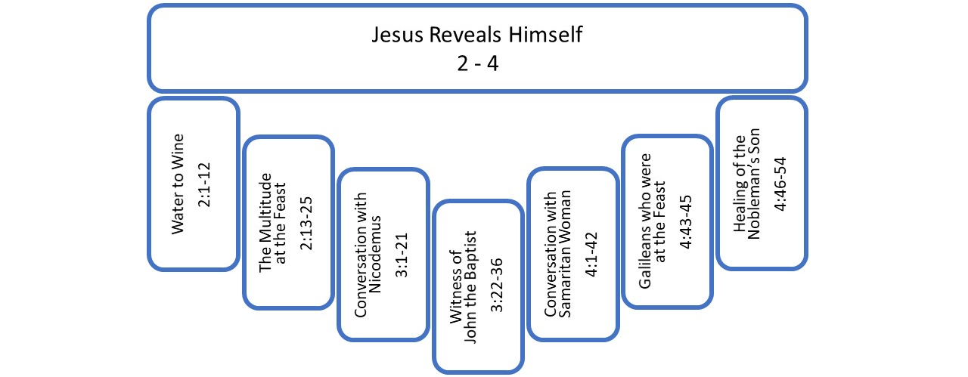
With this lesson, we finish the first section of the Gospel of John, chapters 2-4, which I have been calling “Jesus Reveals Himself.” This is the initial reveal. The Light came into the world. John said, “The Word became flesh, and dwelt among us, and we beheld his glory, the glory as of the only begotten Son from the Father, full of grace and truth.” The Word, the Light became flesh, he became the man Jesus. And we have seen him. He has revealed himself. John’s report of this revelation begins with the first sign at a wedding. At the end of that story John wrote, “This beginning of his signs Jesus did in Cana of Galilee, and manifested his glory and his disciples believed in him.” This is what John has been talking about. They beheld the glory of the Word of God who has come in the flesh as Jesus. They beheld his glory through the actions and teaching and miraculous signs that they saw him doing. Jesus made the glory of his nature known to them.
This Gospel is about the nature of Jesus and Jesus making his nature visible, knowable. We are ending this first section with a second sign also in Cana of Galilee. And this second sign draws in the second great theme of the Gospel, the nature of faith. The second theme considers the human response to the first theme, the nature of Jesus.
In this lesson, I am covering two smaller parts of the larger section. I believe John arranged the whole of chapters 2-4 chiastically with seven parts. The first sign and the second sign serve as the outer frame. The first inner frame consists of the Passover report back in chapter 2 and a report here concerning Galileans who were at that Passover. In this lesson, before we look at the last story, which is the second sign, we need to address these Galileans who were at the Passover. It is quite short, only three verses. Still, it is an independent section in John’s arrangement. It fills out the chiasm, and it provides an important transition, moving us from Samaria to Galilee and foreshadowing what is going to happen in Galilee later in chapter 6.
So, we start with the Galileans at the feast and then move on to the second sign. We start with just three verses, John 4:43-45.

Galileans Who Were at the Feast (4:43-45)
⁴³ After the two days He went forth from there into Galilee. ⁴⁴ For Jesus Himself testified that a prophet has no honor in his own country. ⁴⁵ So when He came to Galilee, the Galileans received Him, having seen all the things that He did in Jerusalem at the feast; for they themselves also went to the feast.
Verse 45 makes the connection for us back to chapter 2, telling us that these Galileans received Jesus because they had “seen all the things that He did in Jerusalem at the feast; for they themselves also went to the feast.” Like Jesus, many of the Galileans travelled to Jerusalem for the feast of Passover. It is not unusual that there were a lot of Galileans there. And some of them saw him clear out the temple, and some of them saw him heal people. They were there when all the buzz about Jesus was going on. “Who is this new guy?” “He is one of us.” “Well, who is he?” So, we start with this connection back to the Passover.
There is also here a strange dissonance in these three verses; something does not seem right. And did you catch it? Did you catch the problem in the text? John tells us that Jesus, “testified that a prophet has no honor in his own country.” But then right after that John says, “the Galileans received him.” Well, that does not sound like no honor. So, what’s going on there? That does not seem to make sense. Why does Jesus point out that there is no honor and then the Galileans show him honor? A number of scholars propose solutions that somehow his own country, “there is no honor in his own country” is not supposed to be equated with Galilee. They are trying to remove the dissonance, to get rid of the tension. I think that is the completely wrong approach. I think John has inserted this tension here on purpose.
When we think back to chapter 2, we might remember that there was similar dissonance there, similar tension with a couple of things John said. He said, “during the feast, many believed in His name, beholding His signs which He was doing.” That sounds like a report of positive belief in Jesus. That’s in 2:23. Then, in the next two verses 2:24-25, we have this,
But Jesus, on His part, was not entrusting Himself to them, for He knew all men, and because He did not need anyone to bear witness concerning man for He Himself knew what was in a man.
Many trusted in Jesus, but Jesus did not entrust himself to the many. That’s a similar tension to what we have here in chapter 4. We have what looks like a positive response to Jesus, but based on his own insight into the hearts of men and women, Jesus does not accept the response as positive. Later, after that incident at the Passover in chapter 2, we see Jesus entrusting himself a bit to Nicodemus, and then, we really see Jesus entrusting himself to the Samaritan villagers. But he did not entrust himself to all these who were said to believe at the Passover. So, we are led to wonder about their belief. What did they believe about Jesus?
And now we come to Galilee, and we are told that many of these Galileans who were there also at that Passover are now receiving Jesus. But as in chapter 2, we are not just told that they are receiving Jesus. We are told something else that Jesus knows, “a prophet has no honor in his own country.” The tone of that comment that throws some doubt onto the reception that the Galileans are giving Jesus.
Just as we are to understand from chapter 2 the reality that it is possible to believe in Jesus without believing in Jesus, here also, I think we are to understand that it is possible to receive Jesus without receiving Jesus. There is an outward receiving. There is a welcoming of Jesus, maybe not so much in Nazareth, according to Mark 6:1-6, but that is not the emphasis of John here. John is indicating that there really were people in Galilee who positively received Jesus. And that sets up a problem for us because Jesus seems to still be holding back from them. Jesus is aware that the positive reception is not fully positive. Not that the people are not sincere. We do not have to imagine them as two-faced or hypocritical. It is actually a more challenging problem. It is possible to receive or believe in Jesus on one’s own terms without receiving or believing in Jesus on his own terms.
Maybe his hometown of Nazareth had some problem with Jesus’ rise to fame. But other Galileans seem quite proud that one of their own would go down to Jerusalem and clear out the temple and do miracles and become known. It is easy to imagine some regional pride. We have this when one of our own goes and makes a name on a bigger stage, as an entertainer or politician or humanitarian or athlete or whatever. But they become famous, and they become known, and they carry our name with them. He is a Galilean. He is a North Carolinian. He is a Dalmatian. He is whatever. And when he or she comes home, we receive them. But we receive them according to the image that we have of who they are to us. We receive them because, their honor brings us honor. There is a good chance we don’t them at all in their true character. And we might not really want to. We want them to fulfill a public role that brings benefit or credibility or honor to us. We receive them on those terms.
I believe the Galileans had an image of Jesus as a political leader or as a prophet or as a miracle worker. That is what they received. They received this definition that they had given to Jesus. Whether they truly have received Jesus or are prepared to truly receive Jesus will be seen as Jesus reveals more of himself to them. How are they going to respond to that? What do you do with Jesus when Jesus starts to make you uncomfortable? When the boxes don’t line up? When life is not working out as you expect it to? When God is not doing what he is supposed to do? When his definition of himself does not fit how you want him to be defined? Or when his definition of himself makes significant claim on you and on your stuff and on your identity?
When that starts to happen, will they treat Jesus like the Samaritans treated Jesus? Is the field white for harvest in Galilee as in Samaria? Will they invite Jesus to teach them about himself and will they receive that - not their image of who they want Jesus to be, but the revelation that Jesus gives - will they receive that?
That is the challenge for each of us. It’s your challenge. Are you prepared to receive Jesus according to his own definition of himself or do you persist in defining Jesus according to who you want him to be? Are you willing to submit to his authority and his demands on you as a human being?
We are going to continue to get into this as we move through the Gospel. How it is with these Galileans will become more apparent as we go along. The very next story gives us reason for both positive and negative expectation. Let’s move on to that story, The Healing of the Nobleman’s Son, in John 4:46-54.

Healing of the Nobleman’s Son (4:46-54)
⁴⁶ Therefore He came again to Cana of Galilee where He had made the water wine. And there was a royal official whose son was sick at Capernaum. ⁴⁷ When he heard that Jesus had come out of Judea into Galilee, he went to Him and was imploring Him to come down and heal his son; for he was at the point of death.
⁴⁸ So Jesus said to him, “Unless you people see signs and wonders, you simply will not believe.”
⁴⁹ The royal official said to Him, “Sir, come down before my child dies.”
⁵⁰ Jesus said to him, “Go; your son lives.”
The man believed the word that Jesus spoke to him and started off. ⁵¹ As he was now going down, his slaves met him, saying that his son was living. ⁵² So he inquired of them the hour when he began to get better. Then they said to him, “Yesterday at the seventh hour the fever left him.” ⁵³ So the father knew that it was at that hour in which Jesus said to him, “Your son lives”; and he himself believed and his whole household. ⁵⁴ This is again a second sign that Jesus performed when He had come out of Judea into Galilee.
Concerning the identity of the nobleman or royal official or however your Bible translates his title, D. A. Carson writes this,
The Greek word for royal official, basilikos, sometimes rendered ‘nobleman,’ probably refers to someone officially attached to the service of a basileus, a ‘king’ – here doubtless referring to Herod Antipas. He was tetrarch of Galilee from 4 BC to 39 AD and not properly a ‘king’ at all; but he was popularly considered one (Mk. 6:14). There is no evidence that this official was a Gentile.
So, that’s the kind of man we are talking about. He is a wealthy, connected Jewish man from Capernaum in Galilee. And he has a son who is sick. He is ill to the point of death.
Two details of this story stand out to me as challenging and important for our interpretation.

“Unless you see signs”
The first is what Jesus says to the man after the man pleads with Jesus to come and heal his son. This is the translation in the ESV, “Unless you see signs and wonders you will not believe.” That translation leaves in place a deficiency in English. Since we use “you” as both a singular and a plural pronoun, you don’t know which it is except by context. And here you would assume the “you” is singular since we are told Jesus is talking to the man. But like a lot of other languages, Greek has a singular “you” and a plural “you.” And the one here is plural.
My Bible tries to help us see this in English by translating Jesus’ response, “unless you people see signs and wonders...” We could also use the Southern plural, “Unless y’all see signs and wonders, y’all just won’t believe.” That’s quite fair to the Greek. I apologize for that long explanation for all y’all whose language makes that obvious when you read it the first time. This is a particularly English problem.
So, the odd thing we need to pay attention to is that Jesus responds to the request of the nobleman with a challenge, and he is making that challenge in the plural to more than just the nobleman, if to the nobleman at all. It is an odd way to respond to the request for help. But maybe not so odd for Jesus, since he often responds in unexpected ways. He keeps you on your toes. He makes you think.
We can try to imagine what is going on. I imagine that the nobleman comes up to Jesus and begins to implore him publicly. As usual, there are people around Jesus. And I can imagine that Jesus’ speaks not to the man – He is looking at the man. He is having a conversation with the man – but at this point he is really speaking to the crowd. He might even start to look around at the crowd. I think Jesus is challenging these Galileans that John has already mentioned. This challenge is connected back to that little, short section about Galileans who receive without really receiving.
Jesus says, “Unless y’all see signs and wonders you will not believe.” The Galileans who received Jesus in verse 45 had seen the signs he did at the Passover in Jerusalem. Jesus knows that the many who believed and the many who received did so because of miracles. They believed something about Jesus’, something about his ability to do miracles. They did not necessarily have insight into who Jesus truly is or have a willingness to submit to Jesus’ own self-revelation. Signs faith does not necessarily translate to saving faith. They can be two different things.
Jesus is aware of the expectancy of these Galileans. They are hanging around to see him do something. He is also aware that they lack the spiritual insight or willingness to interpret the signs rightly. Isaiah had said long before that, “When God’s salvation comes] then the eyes of the blind will be opened, and the ears of the deaf will be unstopped. Then the lame will leap like a deer, and the tongue of the dumb will shout for joy (Isaiah 35:5-6).” These are the types of signs that are happening around them. But it is not clear at all that people are making the right connections that the prophet would have them make. They saw the signs without seeing Jesus.
As far as we can tell, the Galileans received Jesus as a miracle worker. Jesus, knowing what was in their hearts used this opportunity with the nobleman to challenge those present who were waiting and watching for Jesus to do more miracles. He speaks past the nobleman to those gathered saying, “Unless y’all see signs and wonders you will not believe.” And I think we are to take the tone of Jesus as going to suggest, “And even in seeing signs and wonders you will believe only what you want to believe.”
Can true faith come from belief initiated by miraculous signs? Well, that brings up the second interesting detail we need to pay attention to. The text is going to say twice that the nobleman believed. And it seems his belief is strengthened through the fulfillment of a sign. If the Galileans teach us to be cautious about sign belief, what about the nobleman?

“He himself believed and his whole household”
On his way, the man’s slaves met him to report that his son had recovered. Apparently, the trip to Capernaum was of some considerable distance to wherever Jesus was, since the healing happened at 1:00 in the afternoon the day before the nobleman met his servants. When the nobleman realized that the healing happened at the exact moment Jesus declared his son well that realization led to a second statement of belief. John had written that he had believed and started off, now John writes, “he himself believed and his whole household.”
This second statement of belief is connected to the miracle, the sign. We are not told that the man believes more about the nature of God. Though it is easy to imagine he did. Who declares by his word and immediately heals a person miles and miles away? Who does that? What kind of man is this? Jesus is the kind of man who has the power to give life by his word. In the next chapter, John will show Jesus claiming that just like God the Father, God the Son “gives life to whom he wishes.” That is what Jesus has just done in the physical realm. He has given life to the nobleman’s sick son, according to his own will to do so. This theme of life is going to continue to play out and it is going to increasingly be heightened. Jesus here gives life to a sick son. Later, he will give life to a dead man. Later still, he will give life to himself after his crucifixion. These miracles, so visible in the physical realm, affirm Jesus’ claim over the spiritual realm. Jesus has the power to regenerate the soul, to give living water, to provide eternal life.
What did this man believe, he and his household? We do not know for sure. That is not a part of John’s story. I think eternal life has truly come to them. I think that is the implication. I think John is setting up for us here a general lack of insight into the signs of Jesus compared to this less frequent case of true belief. I think they got it.

Sign faith
There is an ambiguity to faith based on an experience of miraculous events. When people have these experiences and that causes them to believe, you don’t really know where they stand spiritually. For the disciples at the wedding feast, the first sign found eyes able to see in the miracle the glory of the one who performed the miracle. Jesus manifested his glory, and his disciples believed. Here with the nobleman it also seems that the sign has found hearts open to receiving truth about Jesus.
But a miracle is only an effective sign if the message of the sign is received. And reception is a spiritual act that includes understanding by the mind and a willingness of the heart. It seems this nobleman and other family members and servants in his household had their hearts open to receive the message of the sign.
We see through this man and through the disciples that miracles can be effective as signs, directing people to deeper truth about Jesus.
Yet, Jesus challenge of the Galileans who saw his signs in Jerusalem warns us not to put too much credit in a human response to miracles. People want things and are glad to receive those things. People are amazed at the miraculous and will give acclaim to people who perform them. People will make all sorts of promises when God shows up and acts on their behalf. But the hearts of men and women are blind to spiritual reality, unless God does a work in them. Miracles do not change the hearts of people. God changes the heart. God opens the eyes. Seeing a miracle is not the same thing as seeing Jesus.
Nicodemus saw the signs and even concluded that Jesus was from God. But Nicodemus was not able to move on from there to receive more about Jesus. He could not see Jesus. Not yet, at least. The Samaritan woman experienced a sign from Jesus when he told her about her life. And she responded. The eyes of her heart were opened to see. The rest of the Samaritan villagers followed without seeing a sign. They believed based on her testimony, and then more importantly based on the Word of Jesus. They just believed in the word, not on the miracles.
The person who truly believes, is the one who sees and receives Jesus as the Christ, the Son of God, and continues to receive the Word of Jesus as Jesus further reveals himself. That continually reception, that willingness to learn from Jesus is a mark of true faith. It shows that the eyes of the heart have in fact been opened. As we press forward in our study John’s Gospel, we are going to keep our eyes open for further examples of how Jesus’ word and how his signs relate to the faith of men and women, to the response that he is given.

Conclusion
We conclude here the first section of the first part of the Gospel of John. This first part, chapters 2-12, presents Jesus as the Word Among Us, showing Jesus active in his public ministry. And this first section of this first part describes Jesus’ initial self-witness as he reveals himself in Galilee, Judea, and even in Samaria. The section was bordered in the outer frames by two signs that speak to the nature of Jesus as the creator who brings life. The first inner frame raised the difficult problem of human faith, giving us two examples of people who seemed to believe without believing and receive without receiving. The second inner frame provided a contrast between Nicodemus and a Samaritan woman to introduce to us the reality of internal, spiritual regeneration which is necessary for eternal life. You must be born again. You must drink the water of eternal life which comes through faith in Jesus. We were also challenged in that contrast in our thinking about who is most likely to come to true belief, well, certainly the moral priest. No, the Samaritan woman. Then the central section presented the testimony of a true disciple, John the Baptist, who understood Jesus, according to the self-revelation of Jesus and who understood himself in relationship to Jesus. His joy was not in his own glory, his own increase. His joy was in the increase of Jesus. As Jesus was glorified, John the Baptist’s joy increased. That’s the first section of the Gospel of John, chapters 2-4
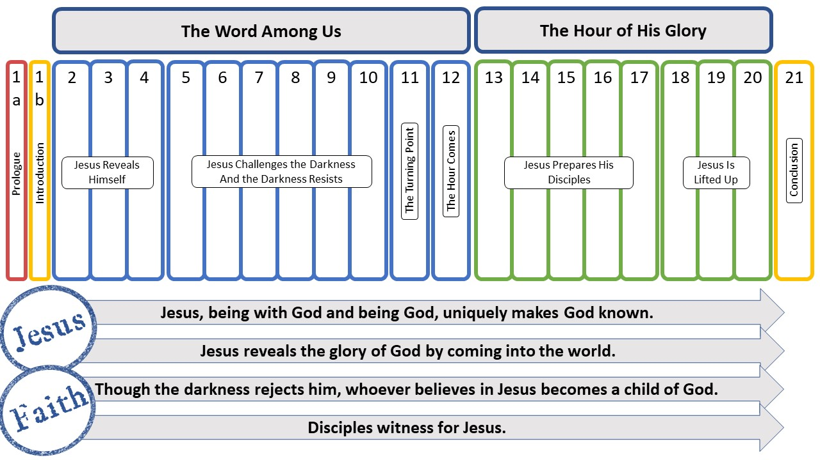

.

Moving on to the second major section in this first part of the gospel, chapters 9-10, John will continue to give witness to the nature of Jesus and the nature of faith. We are going to continue to see both themes. This next section will also be bounded by two of the seven signs, just like the first section. We will start with the third sign which is the healing of the lame man and end with the sixth sign which is the healing of the blind man. And in this section, as Jesus continues to shine as the light of the world, we are going to see increasing opposition against him. This is just as John indicated in his prologue, “the light shines in the darkness and the darkness did not comprehend it [or overcome it]…he came to his own and those who were his own did not receive him (1:5, 11).” But there is always hope in John. There is always hope in life. There is always hope in Jesus. And this is the hope, “But as many as did received Him, to them He gave the right to become children of God (1:12).”

Reflection questions
1. Read John 4:43-54. What stands out to you as interesting, important, strange or confusing?
2. Compare 4:43-45 with 2:23-25. Does the dissonance or tension stand out to you in each passage? Would you agree that these passages suggest that some are believing without believing or receiving without receiving? Or would you explain the tension in these two passages in a different way?
3. How does the depiction of Galileans in the story that follows in 4:46-54 add to your understanding of verses 43-45? (If you are reading in English, remember that the you in 4:48 is plural in the Greek, so addressed to a group even though Jesus is speaking to the nobleman.)
4. Agree or disagree: If we could experience more miracles of power in our Christian communities, more people would believe in Jesus.
5. How do the encounters various people had with Jesus in chapters 2-4 help you understand the role of signs?
6. Considering the Samaritans, the Galileans and the Nobleman, what do you think must happen for a person to come to faith in Jesus?

