Lesson 4: Genesis 12-15 Abraham, part 1

Introduction
The story of Genesis begins with God creating a new environment called the heavens and the earth. He created this environment for humankind, beginning with Adam and Eve as King and Queen. God gave them a great commission to rule over the creation, to multiply and fill the creation, and to reflect his image in the creation.
And yet, the creation is not primarily about man and woman. It is primarily about the glory of God, the fame of his name. God is the center of all things from which all good emanates. The spread of God’s glory does not exclude people. It includes people. We are invited to celebrate God’s goodness with God. We are created to enjoy relationship with him and participate in the display of his glory.
The decision of Adam and Eve to turn away from God and choose their own way, resulted in the corruption of both mankind and the creation. We are no longer purely in the image of God. We are now in the corrupted fallen image of Adam. From Cain and Abel through the flood to the tower of Babel, Genesis 4-11 reveals the depravity of the human heart. We are a corrupt race in need of salvation.
What’s the plan? How does God restore a righteous human kingdom on earth with a people dedicated to walking with him and imaging his glory? We have creation and fall. What’s the plan for redemption?

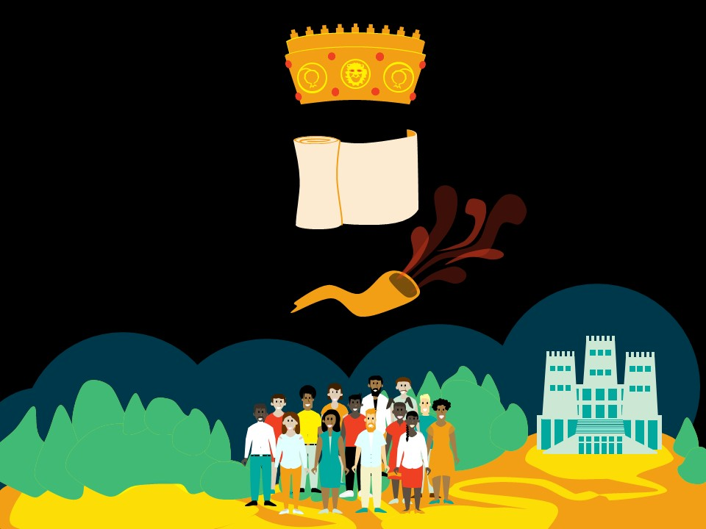
Kingdom and Covenant
Remember in our first lesson I introduced the kingdom motif as a theme that runs through the whole of the Bible. There are six elements to the motif. Kingdom requires a king, a people, a land, a palace, a covenant and a mediator. We could trace the theological development of each of these ideas, each of these elements, through the Pentateuch. I especially want us to keep in mind covenant as the statement of the relationship between the great king and his vassal people.
When I talk about covenant, instead of saying that God made a covenant, I will usually use the terminology, “God cut covenant.” That is the literal translation for the phrase “to make a covenant” pretty much any time it occurs in the Old Testament. Covenants were not made in the Ancient Near East. They were cut. An animal was killed, and the vassal was required to make a self-imprecatory oath, that is to bring a curse on himself if he were to break faith with his suzerain. He was saying, “Let what has been done to this animal be done to me if I break covenant with you my king.”
In our day, we tend to just use signatures and a stamp. When you get married you sign the marriage certificate along with the minister or the civil clerk and a couple of witnesses. That makes the marriage covenant legal. A shotgun wedding would add in the element of the curse. That’s when the daddy of the bride stands in the back with a shotgun to make sure the groom goes through with it and to give him a visible reminder of what is going to come down on him if he breaks faith with daddy’s little girl. The dead animal and the shotgun serve the same purpose.
Here’s an example of a ratification ceremony, or cutting of covenant, from an ancient near eastern suzerain vassal treaty between Ashurnirari V of Assyria and Mati’ilu of Arpad. This is what the tablet says. After decapitating a lamb, this text was to be read.
“This head is not the head of a lamb, it is the head of Mati’ilu, it is the head of his sons, his officials, and the people of his land. If Mati’ilu sins against this treaty, so may, just as the head of this spring lamb is torn off, and its knuckle placed in its mouth, […], the head of Mati’ilu be torn off, and his sons […].
This shoulder is not the shoulder of a spring lamb, it is the shoulder of Mati’ilu, it is the shoulder of his sons, his officials, and the people of this land. If Mati’ilu sins against this treaty, so may, just as the shoulder of this spring lamb is torn out, and […], the shoulder of Mati’ilu, of his sons, his officials, and the people of his land be torn out […] (Pritchard, ANET 532-533).”
So, you get the picture. The covenant is written out. And now Mati’ilu, the vassal, not the suzerain, the lower king, has to go through this ceremony where they take a lamb and cut its head of and rip its leg out and shove the leg in the mouth. And then Mati’ilu is supposed to stand there and say, “If I break covenant with you O great king, then let it be done to me, and not just me but my sons and all my officials, what was done to this lamb. Rip my arms out and stick them in my mouth.” That’s the symbol. And when that was done, when the sacrifice is made and the oath is taken, now the written covenant is legal. It has been ratified.
The great king does not communicate covenant directly to the vassal people. He uses a covenant mediator to do that. There are six primary covenant mediators in the Bible. We call them prophets. But they are a special kind of prophet. Most biblical prophets are not covenant mediators. God does not use them to establish covenant. Most biblical prophets are covenant lawsuit prophets. They bring lawsuit. So, Elijah, Elisha, Isaiah, Jeremiah, Amos, Habakkuk, all these guys were calling people back to covenant faithfulness in relationship to the existing covenant. They are not the ones who established the covenant. That happens only on a rare occasion through a very small number of prophets.
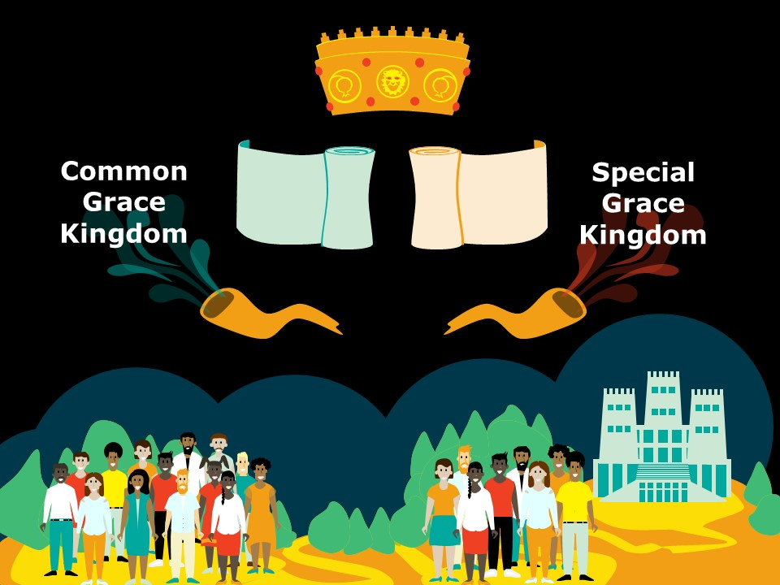
Of the six covenant mediator prophets in the Bible, we can divide them into two categories. There are those through whom God established common grace covenant, that is covenant with all of humankind, and those through whom God established special grace covenant, that is covenant with a special group of people. And there are only two common grace covenant mediators. Both of them are present in the ground we have already covered in Genesis 1-11. So, who do you think they are? Who are the two covenant mediators through whom has God made covenant with all of humankind? If you are thinking of Adam and Noah, you are right. Adam and Noah are our first covenant mediators. Through them God establishes covenant with everybody. Through them there is a common grace kingdom. Like it or not, all humanity is either in covenant with their Creator God or in covenant rebellion against their Creator. There is a common grace kingdom that includes all people.
The next four covenant mediators in the Bible are going to bring covenant from God for a special group of people. We can call this special grace kingdom. Do you know who these four prophets are? When you think about covenant in the Bible, who do you think of? Who brings covenant? Abraham, Moses, David and Jesus. So, there is the Abrahamic covenant, we often call it the promise; the Mosaic covenant or the law; the Davidic covenant which is really with a very special group of people, it is just for his line that the Messiah will come through him and his house established forever; and then, of course, Jesus who brings new covenant, the covenant of grace.
So, now God has moved into the divide and conquer approach. Instead of addressing all humanity at once, he is going to focus in on a special group. It is the next phase in God’s plan of redemption. To this point in Genesis, God has worked with everybody, all of humankind. But after the tower of Babel incident, God separated humanity out from one another, confusing them in their pursuit to establish a name for themselves. The vassals would rebel. They would rule the kingdom of heaven and earth as originally intended by the suzerain king, but they would do so on their own terms, lifting themselves up to the same level as the King of kings, not under him but equal to him. They would make a name for themselves. It’s the voice of humanism. That voice is not new. The voice of humanism rejects that there is something inherently wrong with the human race. It rejects the authority of God. It claims independence from God. And it claims the right to rule equal with God.
God confused this attempted rebellion, and he scattered the people apart into separate tribes, languages, and communities in order to contain their sense of pride and self-sufficiency. And now, rather than offering redemption through a common mediator to all humankind, God begins to work through one new nation. He will make his capital among a special people whose purpose will be to bless the nations of the earth. And he is going to do this with a people that are not a people, a nation that is not a nation. He is going to do this with an older man and an older woman who have not been able to have any children. Genesis 12 begins the story of redemption, and it starts with the call of Abraham.

Promise Made (12:1-3)
Surveying Abraham’s story creates this frustration in me at how little information we have on the life of the father of our faith. One Harry Potter novel gets 900 pages for one year in the life of a fictitious magician. And all we have are 10 or 12 pages for the full life of Abraham. I’d love to know more. I want more information. Wouldn’t it be great to have a book on the life of Abraham written by someone who was there with him? I guess we are going to have to wait to talk to him in person. For now, I am reminded of how important what we have is. God has given us this for a reason.
When you read the story of Abraham from Genesis 12 to 25 takes us through a series of events that are going to cover his whole lifetime. You are just kind of moving from event to event to event. And it includes dialogue. And it’s often between Abraham and God. And what is said and what is done are both very important, inviting us to close attention. Since we are doing an overview, I am going to focus in only on four critical events. These are four covenant events in the life of Abraham. We will do two in this lesson and then two in the next lesson. The four events are the promise made in Genesis 12, the covenant cut in Genesis 15, the covenant sign in Genesis 17, and the covenant test in Genesis 22. So, promise made and covenant cut in this lesson, starting with the promise made in Genesis 12:1-3. Let’s read those three verses.
¹ Now the Lord said to Abram, “Go forth from your country, And from your relatives And from your father’s house, To the land which I will show you; ² And I will make you a great nation, And I will bless you, And make your name great; And so you shall be a blessing; ³ And I will bless those who bless you, And the one who curses you I will curse. And in you all the families of the earth will be blessed.”
This is a great gospel. Can you imagine this? “Abraham, if you trust me, I will give you descendants, land, provision, protection. Not only am I going to give you all your heart desires. Not only am I going to protect you from your enemies. I am also going to make your life matter. I am going to bless the nations through you: descendants, land, provision, protection and purpose.” What would you say to such a gospel?
God’s plan ties back into the previous history. In chapter 11 man reaches up to make a name for himself. Here God reaches down and lifts Abraham up, telling him, “I will make your name great.” God is going to give Abraham a name. His desire is not to keep us pressed down but to lift us up in right relationship with him. We make our name by walking with God, not by breaking away from God.
Along with the reference to name, the reference to nations links us back the previous story to. In chapter 10 we have the table of nations. And so, that is all of humankind, descended from Noah either from Ham or Shem or Japheth. These nations are the ones who sought to make a name for themselves, to make themselves like God, and to these sinful people, this is the plan, the descendants of Abraham are going to be a blessing. So, through Abraham the line of Eve lives on.
So, Abraham believes. He does have to respond in faith. He accepts this gospel. And he sets out to the promised land. The first thing he does is to build an altar and to worship Yahweh. It’s a wonderful sign of his commitment to God. It also seems to contain a sense of expectant optimism. It’s like, “Here I am God. You know, I’ve arrived. I am in the promise land. Now what? What’s next? Let’s get started on the getting the blessing and being a blessing.
But what happens next in the story. Well, life happens. There is famine in the land. Abraham has to go down to Egypt to find food. And there he is afraid, so he hides the fact that Sarah is his wife. Far from being a blessing to the nations, he becomes a curse. Because God sends a plague on Egypt to protect Sarah. And then they get kicked out of Egypt. And they return to Canaan, probably a bit humbled. Abraham does build an altar again. He is still worshipping Yahweh. But then there is this separation between him and Lot. Lot is not so focused on worshipping Yahweh. He eventually gets mixed up with Sodom and Gomorrah. Abraham has to go on a rescue mission to save him. And then Sodom and Gomorrah get destroyed. And Lot’s wife dies.
The gospel given to Abraham reminds me of the gospel offered to all of us. And how it often works. It really is great news. God has promised us a land. He has promised us heaven, a home, a place, inclusion. He has promised to bless us. He offers us abundant life. He gives us purpose that we can be part of his plan in blessing other people. And God will cause all of it to come true. But that does not at all mean it is going to be easy. It starts with a wonderful gospel, but life is going to be hard. There is going to be suffering. And I wonder if he let me in on how hard serving him was going to be whether I ever would have had the courage to set out. So, I am glad he didn’t. I am glad he waits. I began a bit naïve. I feel like Abraham. He started out with all this hope, but then he began to struggle.
This brings us to chapter 15 and the cutting of covenant. This is maybe 10 years after God’s call came to Abraham. And he still doesn’t have children. This is a very important chapter, so let’s focus in. We are going to go through all the verses of Genesis 15, covenant cut.

Covenant Cut (15:1-21)
There is a pattern to the text. First, God speaks, then Abraham speaks, then God speaks again. Then in the middle of the chapter, we are told Abraham believes. After that the pattern is repeated. God speaks, Abraham speaks, God speaks. So, we will start with the first half. And we will start with God speaking. This is verse 1.

God speaks (1)
¹ After these things the word of the Lord came to Abram in a vision, saying, “Do not fear, Abram, I am a shield to you; Your reward shall be very great.”
It is a short summary of the promise from Genesis 12, blessing and protection. But when Abraham hears it, he immediately thinks of child. That is the top of his mind. That is the number one blessing he is waiting on. And now we are going to read Abraham’s response. And consider whether this sounds like faith to you. Does it sound like Abraham is trusting God?

Abraham speaks (2-3)
² Abram said, “O Lord God, what will You give me, since I am childless, and the heir of my house is Eliezer of Damascus?” ³ And Abram said, “Since You have given no offspring to me, one born in my house is my heir.”
Is this faith?
Does that sound like faith to you? When I ask this question in class, I get both responses. I get “Yes.” I get “No.”
It is difficult to tell the state of Abraham’s faith at this point. It does not sound like he is trusting God for descendants if he expects to have to adopt his servant as his heir. But you could imagine that Abraham’s complaint is a pleading to God for the how. How God? I want to believe you God. I want to believe you are going to do this, but how? You gave a promise, but my life reality is not matching up with the promise. When this happens to us, when we think we know how things should go, we have expectations and they do not go that way, it can really throw us off. It disorients us. How do I bring these two things together? How do I bring my expectations of God and God’s promises together with the mess and the reality of life? Abraham could say to God, “You said I would have a child, but it has been 10 years. My wife is old and barren. How Lord? I don’t get it. It’s not happening. What’s going on?”
And at this point of disorientation when our expectations do not match reality, unbelief shuts God off. Unbelief becomes bitter, and it turns from God. Belief, in the same situation, cries out to God. The father in Mark 9, whose son is possessed cries out to Jesus, “I believe, help my unbelief.”
There is some weakness in there. There is some struggle. Which is it for Abraham? Is this disbelief, a turning from God? Or is it a cry of struggling faith?
God looks into the heart.
One of the challenges interpreting biblical narrative is that we often get dialogue and action without narration. We are not told anything about what is going on inside Abraham’s heart and or in his mind. And we are not told what God thinks about Abrahams response. We are supposed to follow the story and draw conclusions based on what God says or what God does. Because God responds not only to words and actions but also to what he sees in the person’s heart.
This happens all the time when he is interacting with people. For example, after the miracles at the Passover when many believed, why didn’t Jesus entrust himself to those people? Well, John tells us, “he did not need anyone to bear witness concerning man for he himself knew what was in a man (John 2:25).” He sees past the words, or the profession, into the heart.
There is a great example in Luke 1 with the parallel between Zacharias, father of John the Baptist and Mary, mother of Jesus. Gabriel shows up to Zacharias and says, your wife is going to have a child and Zacharias says, “How can this be?” The same Gabriel shows up to Mary and tells her she is going to have a child. Even more shocked, I imagine, Mary also responds, “How can this be?” Gabriel then strikes Zacharias dumb for daring to ask, “How can this be?”. He is not going to get to talk for 9 months. But to Mary, she asks, “How can this be?”, and the response is like, “Good question. Let me explain.” She is approved. She is not rebuked.
You can be sure that Luke is not unaware of the situational irony he has just put together in the narrative side by side. He includes both stories in the same chapter. And we are supposed to notice the similarity and then that difference. We are supposed to conclude that the difference between Zacharias and Mary is not their words. It is their heart. I believe it is a way of pointing out the faith of Mary.
So, how is God going to respond to Abraham? With rebuke or with explanation? Let’s read what God says. This is in verses 4 and 5.

God speaks (4-5)
⁴ Then behold, the word of the Lord came to him, saying, “This man will not be your heir; but one who will come forth from your own body, he shall be your heir.” ⁵ And He took him outside and said, “Now look toward the heavens, and count the stars, if you are able to count them.” And He said to him, “So shall your descendants be.”
It’s not really an explanation is it? And this is also classic God. God does not tell Abraham how it is going to be or when it is going to be. He is not really answering the question that’s posed. Abraham wants the details. But he is not getting the details. God is just saying, “Trust me. It’s going to work out as I say it will.” It’s not an explanation. It’s an illustration. And it’s encouragement to help Abraham to keep going, keep trusting.
So, how then does Abraham respond?

Abraham believes (6)
⁶ Then he believed in the Lord; and He reckoned it to him as righteousness.
If we are not sure about the state of Abraham’s heart in verse 2, we are now. So, Abraham believes. And that faith is counted to Abraham as righteousness. Abraham does not do any righteousness. He simply trusts in the promise of God. And because of that trust, God declares Abraham righteous.
This promise is about having a child, but not only about having a child. It is about having a child through whom the nations will be blessed. This is God’s plan for the nations. We do not know how clear all of that was to Abraham. We do know he is being asked to trust in God’s plan of salvation. He is being asked to trust in the promise. And he does. And it is reckoned to him as righteousness.
Now, in the rest of the chapter, we are going to get the pattern repeated. God speaks, Abraham speaks, God speaks again.

God speaks (7)
⁷ And He said to him, “I am the Lord who brought you out of Ur of the Chaldeans, to give you this land to possess it.”
This is that next main blessing given to Abraham in the promise of Genesis 12. So, not only are you going to have descendants, but you are also going to get land. Consider Abraham’s response. Again, does this sound like faith?

Abraham speaks (8)
⁸ He said, “O Lord God, how may I know that I will possess it?”
Yes or no, is that faith? It sounds the same, which is really kind of strange because we just had this clear affirmation of faith in verse 6. So, we expect Abraham to be good with the plan.
But it is so human. No matter how real our faith is, we have doubts, we have struggles, we want to know how. And that’s the question Abraham seems to be asking again. He looks around him, and all he sees are Hittites and Amorites and Canaanites. And they have land. They have the towns and the vineyards. What does Abraham have? Nothing. Well, he has a lot of possessions. He has no land. He is moving from well to well to water his flocks. And at the end of his life he is going to have to barter with a Hittite to buy a place to bury Sarah. So, Abraham again is asking, “How?” “I don’t see it God. How? When?”
And again, God does not rebuke Abraham for his questions. He encourages Abraham. But it is going to be with more than an illustration. God is going to do something very special. You know how people are constantly asking Jesus questions, and Jesus’ rarely answers the question? He responds to the question, but you are like, “Where did that come from? What does that have to do with anything? Why did he say that?” It’s like when Jesus told that young man, “Go and sell everything you have and then come back and follow me.” Where did that come from? It is because Jesus hears more than the question. It’s more than the words we say. Jesus hears what is behind the question. He sees the hidden motives of the heart. He is aware of the deeper issue.
I think we have that with God here. Abraham is asking, “How? How can I know I will get the land? Get a son?” Part of the how is looking around at the outer circumstances of life? Sarah is old. The land is already populated. But part of the how deals with our own inner questions, like, “Do I have what it takes to remain faithful? How can I know that I am going to live up, that I will be approved? I hear your promise God, but what about me? How can I know that I am going to remain faithful in order to have the son, in order to inherit the land? How do I know I am going to make the right decisions or do your will?”
And again, I do not know how much of that was clear to Abraham, on the top level of his mind in his thinking. But it is deep in the reality of the human heart, our insecurities of who we are. “What if I don’t have true faith? What if I can’t keep this up? What if I mess it up? I’ve already got strikes against me. Nobody really knows how messed up I am. What if the mask drops? What if I cross the line, and it becomes public?” Have you ever felt that? “What if I get uncovered? What if I have to stand naked and ashamed?”
In answering Abraham’s how question, God is going to let him know what is going to happen to the inhabitants of the land. God is going to solve the outward circumstances. But this answer goes so much deeper to addressing the self-doubts, the weakness, the sin, that is implicit in Abraham’s question.

God speaks (9-21)
This is God speaking again, and it is going to be most of the chapter. It is verses 9-21. Let’s deal with it in two parts. So, first, verses 9-16. This is the part that would have been quite clear to the ancient near eastern reader. They are going to know what is going on, so, 9-16.
⁹ So He said to him, “Bring Me a three year old heifer, and a three year old female goat, and a three year old ram, and a turtledove, and a young pigeon.” ¹⁰ Then he brought all these to Him and cut them in two, and laid each half opposite the other; but he did not cut the birds. ¹¹ The birds of prey came down upon the carcasses, and Abram drove them away. ¹² Now when the sun was going down, a deep sleep fell upon Abram; and behold, terror and great darkness fell upon him. ¹³ God said to Abram, “Know for certain that your descendants will be strangers in a land that is not theirs, where they will be enslaved and oppressed four hundred years. ¹⁴ “But I will also judge the nation whom they will serve, and afterward they will come out with many possessions. ¹⁵ “As for you, you shall go to your fathers in peace; you will be buried at a good old age. ¹⁶ “Then in the fourth generation they will return here, for the iniquity of the Amorite is not yet complete.”
Ok. So, the answers clear, it’s not really desirable, that you are going to get the land. It’s just going to take 400 years for your descendants to be able to populate it. So, that is a tough answer. So, Abraham is actually getting some of the details with this answer. But then the whole business of cutting the animals, that is all strange to us. None of it is normal. But it was very clear to the ancient readers. They recognized exactly what’s going on. And maybe you do, too, now. This is the cutting of covenant. God is having Abraham set up an oath ceremony. He has cut the animals, and he has placed them half on one side and half on the other side. That’s normal.
It gets confirmed in verse 18, “On that day the Lord made a covenant with Abram.” And remember that Hebrew word translated in your Bible as made a covenant is literally cut a covenant. So, Abraham is setting up this cutting of covenant ceremony. Does God need to enter into a legal agreement with Abraham? Well, no. God made a promise. That promise stands. God doesn’t need to ratify his own word. God is condescending to use a known human form of agreement, a suzerain-vassal treaty, to communicate something to Abraham. This is not for God. This is for Abraham. And for us.
The first part is known to them, not unusual. The second part is where it gets weird, even for the ancient reader. This is not supposed to happen, verse 17-21 don’t really make sense even to them. Let’s read that.
¹⁷ It came about when the sun had set, that it was very dark, and behold, there appeared a smoking oven and a flaming torch which passed between these pieces. ¹⁸ On that day the Lord made a covenant with Abram, saying, “To your descendants I have given this land, From the river of Egypt as far as the great river, the river Euphrates: ¹⁹ the Kenite and the Kenizzite and the Kadmonite ²⁰ and the Hittite and the Perizzite and the Rephaim ²¹ and the Amorite and the Canaanite and the Girgashite and the Jebusite.”
So, what’s weird about this? The animals are cut and ready, laid out on a path. Who is supposed to walk through the pieces? Abraham. By his action, the vassal communicates to the great king, “If I break covenant with you great king then let it be done to me what has been done to these animals.” But instead we have a smoking pot and a flaming torch passing through the pieces. And that’s what’s weird. Why a smoking pot and flaming torch? And why doesn’t Moses explain this? What does he expect us to think this is? Well, then we ask, “Does the context help us?” Where do we see smoke and fire in the books of Moses? Well, we see smoke and fire in pillars that lead the people through the wilderness. We see smoke and fire at the burning bush. And we see smoke and fire on Mt. Sinai during the cutting of covenant with Israel. And then we get it. Smoke and fire in the Pentateuch symbolizes the presence of God.
God passes through the pieces! Abraham is not even involved. He is put to sleep off on the side. And the great king passes through. That never happens. In essence God is declaring, “If you break covenant with me, then let me die.”
Matthew 27 describes the fulfillment of that proclamation. The great king follows through with his word. From the sixth hour to the ninth, there was darkness on the land. Hanging on the cross, Jesus gave up his spirit. And the temple curtain was torn in two. There was an earthquake. The soldiers were terrified. They were frightened. “If you break covenant with me, I die.” That is what God said. That is what Jesus did. He took the curse.
And that’s how you know that the promise of God is sure. Because it does not depend on you. It depends on God.

The 1st question of covenant
The first basic question of covenant asks, “What makes me acceptable to God?” Or “What makes me righteous enough to be in relationship with a holy God?”
Let’s think of this in terms of grace and law. In this sense, grace is what God does. Law is what you do. So, think of law as the dos and the don’ts. They are the stipulations of covenant. And there is a lot of that kind of law, not just in the Old Covenant but also in the New Covenant. It is all over the place. “Love your neighbor. Be devoted to prayer. Give to those in need. Do not let any unwholesome talk come out of your mouth but only what is useful for building others up. Love your enemy.” These are the stipulations of covenant. The dos and the donts. The law.
Grace is God’s part. Law is your part. So, let’s put this into percentages. What percentage of being approved by God relies on grace, is God’s part? And what percentage of being approved by God relies on you on your obedience or your fulling the covenant stipulations? What’s your part? What’s God’s part? I am speaking at a youth conference this week. And I asked the question to this group of Christian teenagers. And they gave me a lot of possibilities. They gave me 50-50, 50% grace and 50% law. They gave me 99% versus 1%; 100%, 0%; 90%, 10%. So, which is it?
What is the answer for Abraham? How much was him, and how much was God? Well, we go back up to verse 6, “Then he believed in the Lord; and He reckoned it to him as righteousness.” What was Abraham doing during the cutting of covenant? Nothing! He was in a deep sleep as passive as a person can be without being dead. The righteousness you need to make you acceptable to God is not something that you can do. It is only something you receive. It is passive to you. It is active to God. The answer is 100% grace, 0% law. You cannot contribute to making yourself acceptable to God. Either you are completely by the grace of Christ or something depends on you, just that 1%. We will just go 99 and 1 that depends on you. You are going to mess up. You are going to ruin the 1%, by your thoughts, by your words, by your deeds. You will not keep covenant with God.
Paul nails this home in his letter to the Romans. I am not going to go through all that right now. I’ll refer you to the observetheword podcast on Romans if you want to get a more thorough argument of our righteousness by grace through faith, that it is 100% grace, 0% law. Thoroughly covered there. If you just want to jump into the main point, you can go to Romans 3:21-30 or Romans 4, which is where Paul spends a whole chapter explaining this verse Genesis 15:6 as the precedent. Abraham is the precedent for the New Covenant assertion that justification is by grace alone through faith alone. It cannot be part grace and part works. It is either all grace or it is not grace. As Paul says in Romans 11:6, “If it is by grace, it is no longer on the basis of works, otherwise grace is no longer grace.”
Looking back over Genesis 15, I love how the literary structure of the story emphasizes truth about faith and grace. Faith is the human part of being made acceptable before God. So, if we say there is anything you have to do, you have to receive the gift. Faith is necessary. We must trust God and receive his plan of salvation. That is clear. It is right in the center of the text. Abraham believed and was declared righteous.
Yet, on either side of Genesis 15:6, we see that Abraham’s faith does not look that impressive. It looks very human. The strength of the passage is not in the faith of man, but in the grace of God. God’s grace comes at the end of the story and anchors the whole.
So, imagine two guys dared to go out onto an icy lake. And one maybe jumps off a pier onto the ice with great confidence. And the other one, he gets out there, but he crawls out with fear and trepidation. Either way both guys have succeeded in expressing their trust that the ice is going to hold them up. They are putting their faith in the ice. But if that ice is only a couple of inches thick, confident faith verses weak faith just does not matter. Both guys are going through. What matters is not the strength of their faith. What matters is the strength of the ice.
When you jump into God’s arms, the question is not, “How confidently did you get there?” The question is, “How strong are those arms? How committed is God to his own promise?” And he is this committed, “But God demonstrates his own love for toward us, in that while we were yet sinners, Christ died for us (Romans 5:8).” God has declared, “Come to me and believe. You are safe. I have declared that if you break covenant with me, I will die. You are safe in my promise.”

Reflection Questions
1. What stands out to you as you read Genesis 12:1-3? What do you notice as interesting or important or strange or confusing? What questions come to mind?
2. Can you relate to the idea of Abraham receiving a wonderful promise and responding with faith, and yet not fully comprehending what lies ahead? How does that relate to your own experience, walking with God?
3. What stands out to you as you read Genesis 15? What do you notice as interesting or important or strange or confusing? What questions come to mind?
4. How do you interpret Abraham’s questions in verses 2-3 and verse 8? Does that sound like faith to you?
5. Does your own experience of faith resonate with Abraham’s how questions?
6. How do you feel personally about struggling through faith with God, expressing doubts to God, or expressing doubts in front of other Christians? If such expression of doubts makes you uncomfortable, why do you think that is? If you feel freedom to express your doubts and worries to God and other believers, why do you think that is?
7. How do you answer the first question of covenant? What makes you acceptable to be in relationship with God? How much depends on God’s grace? How much on what you do?
8. How would you reword the illustration of the two guys going out onto the ice? Does it speak to you as it is? Or if you were to share it with someone else, how would you adjust it?

